Lab Report No 10

Understanding of Hill Climbing Search and A Star Search
Artificial Intelligence



Submitted By:
[Huzaifa Shahbaz]
[21-CE-009]
[Aqsa Shah]
[21-CE-039]
Submitted to:
Engr. Hareem Khan
Dated:
27thMay,2025
Department of Computer Engineering,
HITEC University, Taxila

Example Task No 1:

Solution:
Brief description (3-5 lines)
A Star Search:
The A* search algorithm is a popular and widely used pathfinding algorithm in computer science. It's particularly useful for finding the shortest path between nodes in a graph, such as in navigation systems or game AI.
The code
import heapq
# Graph structure: Node -> List of (Neighbor, Cost)
graph = {
'S': [('B', 4), ('C', 3)],
'B': [('F', 5), ('E', 12)],
'C': [('D', 7), ('E', 10)],
'D': [('E', 2)],
'E': [('G', 5)],
'F': [('G', 16)],
'G': []
}
# Heuristic values (h(n))
heuristic = {
'S': 14,
'B': 12,
'C': 11,
'D': 6,
'E': 4,
'F': 11,
'G': 0
}
def a_star_search(start, goal):
open_list = []
# Push starting node: (f = g + h, g, current_node, path_so_far)
heapq.heappush(open_list, (heuristic[start], 0, start, [start]))
while open_list:
f, g, current, path = heapq.heappop(open_list)
if current == goal:
print("Path found:", path)
print("Total cost:", g)
return path
for neighbor, cost in graph[current]:
g_new = g + cost
f_new = g_new + heuristic[neighbor]
heapq.heappush(open_list, (f_new, g_new, neighbor, path + [neighbor]))
print("No path found.")
return None
# Run the search from 'S' to 'G'
a_star_search('S', 'G')
The results (Screenshot)
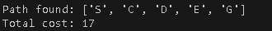
Lab Task No 1:

Solution:
Brief description (3-5 lines)
Implement the A* search algorithm to find the shortest path between two points on a grid.
Task Description:
1.Setup:
Create a grid environment where each cell can either be traversable (empty) or blocked (obstacle).
2.Inputs:
• Grid size (rows and columns).
• Starting point coordinates (row and column).
• Goal point coordinates (row and column).
• Obstacle locations (list of coordinates).
3.Algorithm Implementation:
• Implement the A* search algorithm to find the shortest path from the starting point to the
goal point while avoiding obstacles.
• Use Manhattan distance (or any other appropriate heuristic) as the heuristic function for estimating the distance from each cell to the goal.
4.Output:
• The shortest path from the starting point to the goal point.
• Visualization of the grid with the path highlighted.
The code
import heapq
import matplotlib.pyplot as plt
import numpy as np
class Node:
def __init__(self, position, g=0, h=0, parent=None):
self.position = position # (row, col)
self.g = g # Cost from start to node
self.h = h # Heuristic cost to goal
self.f = g + h # Total cost
self.parent = parent
def __lt__(self, other):
return self.f < other.f
def heuristic(a, b):
# Manhattan distance
return abs(a[0] - b[0]) + abs(a[1] - b[1])
def astar(grid, start, goal):
rows, cols = len(grid), len(grid[0])
open_set = []
heapq.heappush(open_set, Node(start, g=0, h=heuristic(start, goal)))
closed_set = set()
node_map = {}
while open_set:
current = heapq.heappop(open_set)
if current.position == goal:
path = []
while current:
path.append(current.position)
current = current.parent
return path[::-1] # Reverse path
closed_set.add(current.position)
neighbors = get_neighbors(current.position, rows, cols)
for neighbor in neighbors:
if grid[neighbor[0]][neighbor[1]] == 1 or neighbor in closed_set:
continue
g = current.g + 1
h = heuristic(neighbor, goal)
neighbor_node = Node(neighbor, g=g, h=h, parent=current)
if neighbor in node_map and g >= node_map[neighbor].g:
continue
node_map[neighbor] = neighbor_node
heapq.heappush(open_set, neighbor_node)
return None # No path found
def get_neighbors(pos, rows, cols):
r, c = pos
moves = [(0,1), (1,0), (0,-1), (-1,0)]
neighbors = [(r+dr, c+dc) for dr, dc in moves]
return [(nr, nc) for nr, nc in neighbors if 0 <= nr < rows and 0 <= nc < cols]
def visualize_grid(grid, path, start, goal):
grid = np.array(grid)
for r, c in path:
if (r, c) != start and (r, c) != goal:
grid[r][c] = 3 # Path color
grid[start[0]][start[1]] = 4
grid[goal[0]][goal[1]] = 5
plt.figure(figsize=(6, 6))
cmap = plt.cm.get_cmap('Accent', 6)
plt.imshow(grid, cmap=cmap, origin='upper')
plt.xticks(range(grid.shape[1]))
plt.yticks(range(grid.shape[0]))
plt.grid(True)
plt.title("A* Pathfinding Visualization")
plt.show()
# Example Usage
def main():
rows, cols = 10, 10
start = (0, 0)
goal = (9, 9)
obstacles = [(1,1), (2,2), (3,3), (4,4), (5,5), (6,6), (7,7), (8,8)]
grid = [[0 for _ in range(cols)] for _ in range(rows)]
for r, c in obstacles:
grid[r][c] = 1
path = astar(grid, start, goal)
if path:
print("Shortest path:", path)
visualize_grid(grid, path, start, goal)
else:
print("No path found.")
if __name__ == "__main__":
main()
The results (Screenshot)
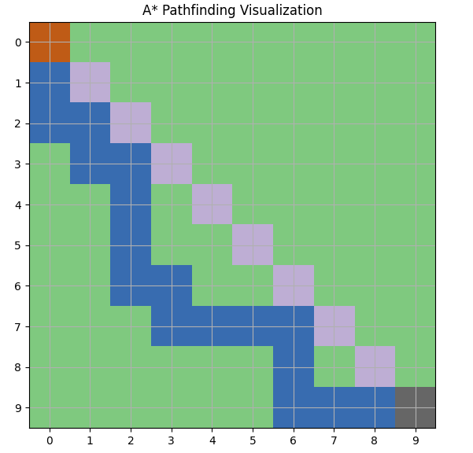
Conclusion
In conclusion, the Hill climbing search is a greedy algorithm that moves towards a goal, while a search algorithm uses actual cost and heuristic estimate to find the most efficient path. Having a grasp of these algorithms allows for a balance between efficiency, accuracy, and computational cost in ai pathfinding.

